**00. Introduction to AWS NLB 6 Demos**

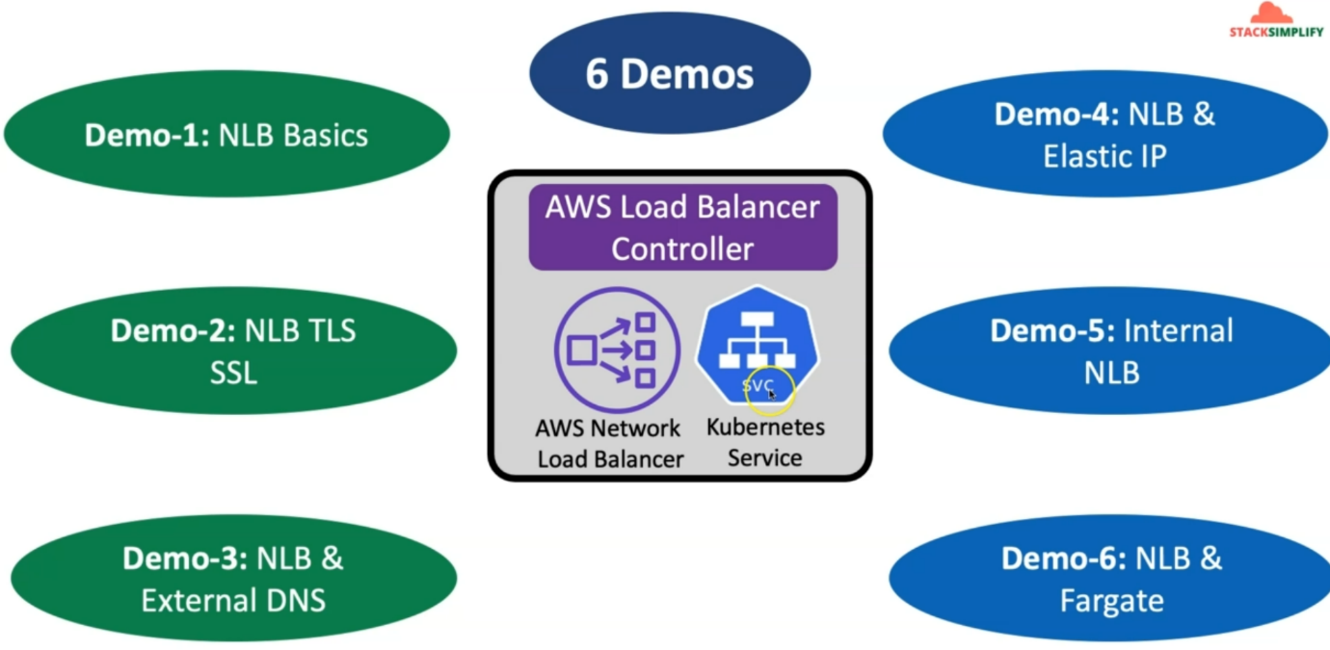

--- as part of this section, we are going to create an AWS network load balancers using Kubernetes service on ECUs cluster.

--- as part of Ingress, when we are learning with application load balancer, alb ingress. we already installed the application Load Balancer controller.

--- The Same Load Balancer controller will be able to create the aws network load balancer whenever we use the Kubernetes object of type service.

--- using that, we are going to create six demos and understand your network load balancer using Kubernetes service, which means we are going to declaratively right the configuration in Kubernetes k8s Yml manifest and create the AWS network load balancer related use cases.

--- **DEMO 1** - in the demo one, we are going to understand and implement **nlb** basics, which means all the important annotations related to NLB basics.

--- We are going to write it and understand them from that Kubernetes service perspective.

--- **DEMO - 2** - we'll move on to the next demo, which is NLB TLS SSL, which means we are going to implement SSL for our network load balancer from Kubernetes service.

--- **DEMO - 3** - From there will move on and also implement the NLB and then external DNS. how we have implemented the external dns use case in application load balancer. same way we will also update the annotations related to external DNS in Kubernetes service and ensure that NLB DNS also successfully registered using external DNS in Route53.

--- **DEMO - 4** - will also implement NLB and Elastic IP

--- **DEMO - 5** - as part of demo 5, we will also implement internal network load balancer and we are also going to test that with the curl pod.

--- **DEMO - 6** - as part of Demo 6, we will also implement network load balancer, sending the traffic to the pods running on the faregate infrastructure, which is a serverless infrastructure from AWS perspective.